E-learning interface for educational action research

Janis Kapenieks
Riga Technical University
Janis.kapenieks@gmail.com

Abstract

The study aims to bridge the newest information and communication technologies and action research which has come to be known as a modern inquiry driven learning method and also a learning strategy. To this end, the paper presents a research into the effectiveness of action research as an e-learning method, notably, identifies the basic principles of the e-learning environment, explores the importance of constructive supportive dialogue and discusses the creation of a model of interface for educational action research (EAR) in an e-learning environment.
The paper analyses an experience from a Business course implemented in an e-learning environment at Riga Technical University over a two-year period. Statistical analysis of the characteristics of students’ activities and self-appraisal has been performed. The basic principles and the prototype of an interface developed in the course of the study take into consideration pedagogical theory and the previous experience of designing e-learning environments.
Thus, the study: (1) discusses the advantages and disadvantages of EAR in an e-learning environment in the context of sustainable education and (2) evaluates the adequacy of the developed interface model to the user’s cognitive needs. The proposed methodology suggests new possibilities for creative cooperation in an e-learning environment for sustainable ubiquitous education.

Keywords: action research, e-learning, learning environment, ICT, user’s interface

Introduction

Since the middle of the 20th century, action research (AR) has been developed as a qualitative research method. At the same time, action research is an educational means for the research participants. Action research generates new knowledge which is gained by learning how to change the given situations or solve important problems facing the AR participants. The AR participants take decisions based on the obtained results at the same time gaining new knowledge. The creation of meaningful theory in action research forms the basis for the construction of shared local understanding of the community members, which is often expressed in critical attitudes to more dominant discourses (Genat, 2009). Reflection and conceptualisation of action in collaborative group work facilitates the acquisition of situated knowledge. Collaborative research projects and their assessment give confidence to the participants and reduce their trust in authoritarian knowledge (Dick, 2009). The use of action research in generating knowledge influences the research participants — both the researchers and the students. Educational action research (EAR) encourages the research participants to get involved in addressing present–day problems in a definite environment, in which the use of modern information and communication technologies enhance the potentialities and the results of AR. The use of action research in an e–learning environment for educational purposes lends new opportunities to organizing the process of research.
With the entry of the new information and communication technologies (ICT) into everyday use, the implementation of a sustainable education process poses new demands to the technologies and the learning methods. In the last twenty years, this theme has been addressed from various perspectives, which have resulted in a diversity and wealth of experience and approaches to the use of ICT for educational purposes. In this article, we shall proceed from the undeniable truth that in e–learning the computer plays an important role and consider this idea from the perspective of sustainable education. Computer–based learning requires an appropriate computer interface design. From the point of view of its function, the computer interface design: (1) helps to develop the user’s cognitive faculties in the learning process and (2) has to comply with the learning method and strategies used in education (the present study centers on e–learning needs). Thus, it is important to find out in what way the computer interface facilitates the acquisition of information, encourages communication, supports the process of mastering and generating knowledge and helps to perform other important tasks essential for the method.
The paper sets out the basic principles of computer interface design which were revealed and defined in educational action research (EAR). The EAR was implemented in an e–learning environment as the best way to maintain the research participant collaboration and obtain learning results through dialogue and individual studies and research. The AR environment was used in order to: (1) check whether it was possible to implement AR in the form of e–learning and (2) investigate what kind of computer interface was necessary to satisfy the needs of EAR. Within the framework of the study, a new model of the e–learning environment answering the needs of EAR has been developed. The research has been carried out at Rīga Technical University over the period of two years, and 262 students have taken part in it.
The information and communication technologies (ICT) are traditionally used in education for information transfer or collaboration in an e–learning environment. Initially computer based learning centered on copying the traditional transmissive (autoritarian or autocratic) learning style, transmitting knowledge from the computer to the learner. Even today the main motivation for e–learning is often an easy and cheap way to provide the learners with the study content. In the course of time, computer supported collaborative learning (CSCL) both synchronous and asynchronous, was developed. This pedagogical approach favours learning in social interaction via the internet (Stahl, 2006). From the very beginning, the following two learning methods were distinguished (Dillenbourg, 1999):
• Cooperative learning in which the learners solve individual tasks the outcomes of which are summarized in a common result;
• Collaborative learning in which the partners work jointly.
Collaborative learning is a social activity which is based on the construction of shared knowledge in collaborative problem solving (Roschelle, 1995). The computer gives the consultant the possibility to offer various materials, including simulation and interactive materials. The learners use them not only as a source of information, but also as a problem solving tool searching answers to issues suggested by computer simulation. In collaborative learning the learners look for information in the internet, discuss it together, summarize and present it constructing a discourse. This gives the consultant the possibility to motivate the students and guide them imperceptibly, creating the effect of social presence from anywhere in the world (Stahl, 2006).
With the collaboration process growing in importance and the collaboration–based approach to the learning process developing, the problem of the computer interface design became urgent for maintaining the learning activities and diversifying them.
Two contrasting approaches to design developed — for acquiring multimedia knowledge and for constructing multimedia knowledge (Mayer, 2001). R. Mayer distinguishes three approaches used in the multimedia interface screen: –device based, represention–based and user perception–based ways of presenting instructional information. Two approaches to multimedia design correspond to them (Mayer, 2001):
• Technology–centered approach, seeking an answer to the question — how can we use the available technological resources for our needs? Its aim is access to information.
• Learner–centered approach, seeking an answer to the question —how can we adapt the available technological resources in order to improve the learning process? Its aim is support to knowledge construction and acquisition.
In the process of developing these approaches three characteristic conceptions explaining the problem and defining further research have crystallized. Initially, emphasis was laid on the notion of a user–friendly interface which turned with time into a characteristic feature. J. Nielsen suggests five attributes (features) to explain the notion (Nielsen, 1993):
• Learnability – which characterises the time a novice user needs to acquire knowledge and achieve an expert user’s level of proficiency;
• Efficiency – which characterises how quickly and easily the expert user performs his/her tasks;
• Memorability – which characterises the effort with which the user remembers previously acquired procedures ande tasks;
• Easy error recovery – which characterises how quickly and easily the user continues work after having committed an error; fatal errors indicate deficiencies of design;
• Subjective satisfaction – which indicates whether the user is satisfied and gladly performs his tasks.
These requirements for the interface design of the e–learning environment lie at the basis of the main objective of this paper, i. e., to develop the basic principles of the interface design for an e–learning environment complying with the requirements of educational action research (EAR) and promoting the effectiveness of this method in acquiring knowledge (Kapenieks, 2011b). The basic principles of a user–friendly interface for learners, study consultant’s and researchers have been analysed in the paper. A user–friendly interface is easy to use, takes the peculiarities of the user’s perception as well as the basic requirements of the cognitive system into account (Lund, 1997).
The study attempts to find answers to questions oriented towards finding a user–friendly design for maintaining and facilitating action research in an e–learning environment. First it was necessary to find out how to implement EAR within the existing random access resources according to R. Mayer’s first approach focused on using technologies for the learners’needs (Mayer, 2001). The next study problem centers on examining how EAR in an e–learning environment influences the learners’ creativity in group work. The third question answered in the study is what kind of e–learning environment as a component of the study environment in EAR fosters knowledge building? The answer to the last question comprises two components: the comparison of the architecture of an e–learning environment in random access resources with updated architecture and the development of the basic principles of a user interface which stimulates the cognitive processes and the perception. The structure of the paper is based on the search for answers to these questions. The research has resulted in developing a prototype of an e–learning environment design in EAR according to R. Mayer’s second approach to the e–learning environment design focused on knowledge construction (Mayer, 2001).
The research was carried out in a synchronous and asynchronous e–learning form at the Faculty of Electronics and Telecommunications of Riga Technical University involving 9 groups of full-time first-year bachelor students doing a Business course in the autumn semester of the 2009/2010 study year. Also he students of 3 groups doing a Business course in the autumn semester of the 2010/2011 study year were involved in the research. 256 students whose studies are connected with a wide use of information and communication technologies were involved in the main research cluster. They are expert users of the computer and the ICT are an essential part of their study process.
Within the framework of the research, the students in five person groups performed 3 learning cycles of educational action research in an e–learning environment which was based on Google Docs potentialities. In each learning cycle in their Business course, they created their personal living theories in debates by reflecting on their business ideas. Before starting educational action research and at the beginning of each learning cycle, the students appraised their personal interests and values. The research includes analysis of the students’ discussions and of the content of their living theories as well as the characterization of their creativity and of the development of their interests during the semester. In a poll, the students assessed the effectivity of the method used in acquiring knowledge and the user–friendliness of the interface employed.

1.The conceptual framework of the study questions

The aim of the study is the definition of the basic principles of the interface and the development of practical proposals for the interface design which has to maintain and facilitate the implementation of action research in an e–learning environment. Based on these principles, the architecture of an e–learning environment and a prototype of an e–learning environment interface have been elaborated. The research has been conducted in several stages as seen in Figure 1.

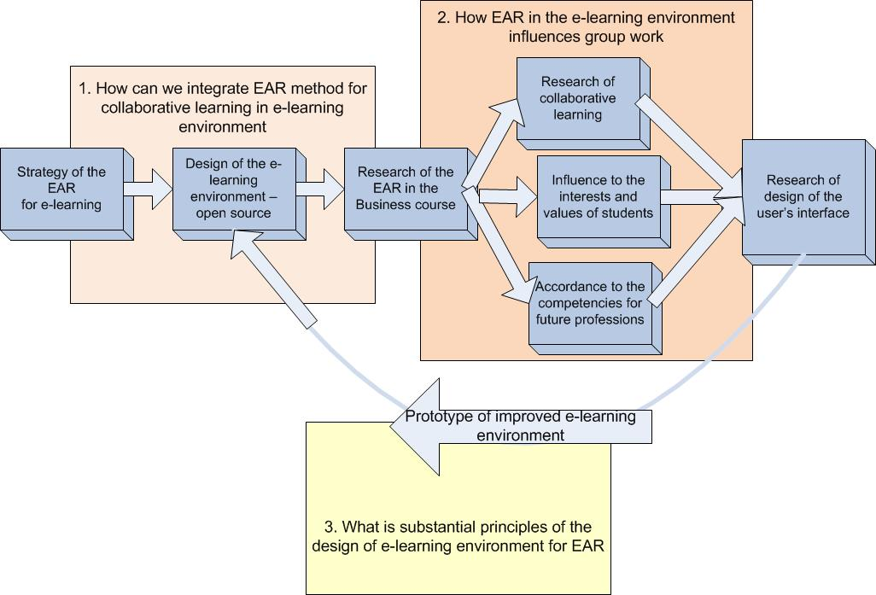

Figure 1. The research questions and algorithms

The first batch of questions concerns the problem of how to develop an e–learning environment design for EAR group work using the available resources. At Riga Technical University the e–learning environment of the course for joint work in the internet has been incorporated in the portal ORTUS designed by the open source MOODLE software and Google Docs random access potentialities have also been taken advantage of.
The second batch of questions concerns the results of using the EAR method in an e–learning environment. These are questions of how the method influences group work and how leaders are formed, what impact the method has on the individual and the results of knowledge acquisition. The study poses also the question of whether the impact of the method on the individual answers the needs of professions which would be in high demand in the nearest future.
The third batch of questions concerns the e–learning environment design for the EAR method. These questions are:
• What kind of e–learning environment design is necessary to make the EAR group method maximally effective?
• What are the basic principles of e–learning interface design for effective group collaboration?

2. Action research in an e–learning environment as educational innovation

Knowledge society is based on a new paradigm in our attitude to knowledge. Synergy exists between the paradigm of knowledge society as the framework of a generally accepted set of provisions and considerations determining the progress of events and the type of activity (Robinson, 2011) and the development of the information and communication technologies. The characteristic features of knowledge society are diversity of opportunities, freedom of opinion and the right to participation (UNESCO, 2005). The ICT provide not only ample opportunities for cooperation, but also ensure access to an immense amount of information which requires new competences for its assessment. The use of information technologies ensures the most essential demands of 21st century education: personalisation, adjustment to the learners’ needs, efficiency and effectivity (Salmon, 2002). Technologies have a crucial role in students’ lives, they encourage them to make the learning environment innovative and creative. The skills of the students and the educators and the new technology–based educational systems define the new learning culture at the centre of which is the learner (Ferrari, 2009). The level of interaction and cooperation skills with the new technologies determines the mode of acquiring knowledge and personalisation (Ala-Mutka, 2008). The new generation grows and develops in an environment pervaded by the new technologies, it is often alluded to as the NetGen or the Google generation (Herold, 2009). The ICT release their creativity. Blogs, social networks, multimedia application sharing and online games have become tools that teach young people how to learn, which, according to C. Rogers’ view, is one of the most important components of creativity (Rogers, 1983). New ways of applying the ICT have changed the aquisition and construction of knowledge. Collaboration in local communities has been replaced by collaboration in relational communities (Bess, 2002). The development of collaborative learning stimulates the appearance of new trends and directions in pedagogics and poses the question — how do we learn today and how to avoid offering the outdated education to the net generation (Prensky, 2005; Loveless, 2007). A. Loveless considers that the use of technologies is stimulated by the user’s awareness of their potentialities. He speaks of the “active learning process” (Loveless, 2008) which significantly enhances the learning opportunities and offers new ways of shared problem solving and knowledge construction.
The presentday wealth of information gives the possibility to create necessary knowledge challenging the educators to acquire the skills needed to build new necessary knowledge. According to J. Dewey’s educational philosophy principle the teacher’s task is to encourage and motivate the students to acquire knowledge rather than to deliver knowledge (Dewey, 1997). According to Vygotsky’s activity theory which is rooted in his cultural–historical psychology, the internalisation and externalisation of the cognitive processes take place with the help of tools and represent purposeful interaction of the subject with the object. These tools embody the mental processes and manifest themselves in physical or psychological constructs (Kaptelinin, 1999).
The provisions dictated by the learning environment correspond in an idela case to J.Dewey’s criteria for the learning environment (Dewey, 1997; Hansen, 2002). The learning environment has to be simple, respect the abilities of the learners, designed with the aim to develop these abilities; the learning atmosphere has to be benevolent stimulating the wish of the participants in mutual interaction to listen to other people’s opinions without making premature conclusions. The right balance in interacting with other learners promotes personal social and moral growth. If the learning environment is stabilising, it respects the interconnectedness of all spheres of life and is directed towards harmonising knowledge (Hansen, 2002). If the technological solution of the learning environment is based on the ICT, the students’ computer literacy has to be taken into account, they have to be listened to and their opinions respected, and their responsibility stimulated by cooperating with them in the social networks. The internet unites all spheres of life, the boundaries of which are sometimes difficult to identify (Kapenieks, 2010). Computer interface solutions for learning which enhance collaboration have turned out to be more effective than the “explanatory” designs meant for individual use (Baker, 1997).
Activity Theory in HCI (human-computer interaction) describes targeted interaction between the subject and the object in the world of physical and psychological mediators (tools, means) (Kaptelinin, 1999). Using the action research method as a learning tool for interaction between subjects has a decisive role. In a computerised learning environment, the relationships between the “ways of knowing” exist at different collaboration levels: as self-action, as inter-action and as trans-action. In self–action things are viewed as acting under their own powers, in interaction thing is balanced against thing in causal interaction. In both cases, they are oriented towards a clearly defined result.The transaction (collaboration) theory describes modern complex systems whose correlations and descriptions contain various aspects. These systems are not oriented towards ultimate and final conclusions and results.
Transactional observation using action research in the knowledge construction process and employing the modern information and communication technologies, is an effective method of personal development. Action research performed by the author of the present paper with bachelor student groups in an e–learning environment as a knowledge creation method has revealed two tendencies:
- introducing tendencies that foster knowledge acquisition into group-work, which differ to a great extent from action research tendencies in the contact group (Kapenieks, 2011b) ,
- stimulating the development of the students’ interests and values in accordance with the needs of the professions which will be in great demand in the nearest future (Cedefop, 2008; Kapenieks, 2011a).
The author’s study has proved that it is possible to assess the students’ achievement in constructing personal knowledge by action research in an e–learning environment. In an e–learning envirinment, the students’achievements and results can be measured. It gives also the possibility to evaluate the students’ creativity as one of the most important components of knowledge construction. The assessment showed that most students are able to generate new ideas by reflection in a discourse, at the same time accepting also the ideas of their group mates and incorporating them in their living theories (Kapenieks, 2011b) .These living theories according to J. Whitehead’s theoretical approach to education manifest themselves as means or tools for problem solving and are heuristically open, creating a favourable environment for discourse in the group (Whitehead, 2009).
The author’s study shows that student groups performing action research in an e–learning environment are rather homogeneous in their activities and creativity. No one dominates the learning process, allowing each person to express himself/herself individually (Figure 2).

Figure 2. The number of discursive ideas in an action research cycle characterising the students’ creativity based on the sequence of the students’ involvement in group–work (Kapenieks, 2011b) .

The study shows that on the average, students who have mastered the course well are more creative than the rest with the exception of those students who received maximum points (in the scale from 1 to 10), their average level of creativity was a bit lower than the level of those students who had received 9 points which proves the fact that excellent knowledge is not always a sign of creativity (Kapenieks 2011b) .
The technical solution of action research in an e–learning environment is based on Google Docs software. Though many sudents consider it rather handy yet the standard design has several serious limitations. As the main objective of the study is to create an optimal e–learning environment, it is important to understand the main rules of cognitively favourable environment for educational action research. The principal requirements have been already reviewed. Now we shall examine the requirements important for the environment and its interface design.

3. Theoretical approach to the requirements for an e–learning environment and interface functions in action research

In order to analyse the cognitive process we shall compare widely known models — Bloom’s taxonomy of cognitive processes (Bloom, 1956) and G. Salmon’s five–step model of collaborative e–learning. (Salmon, 2002) — with the action research model and the stages of its practical implementation in the Business study course carried out by the author of the study (Kapenieks, 2010b). The comparison of the relevant models has been presented in Figure 3.

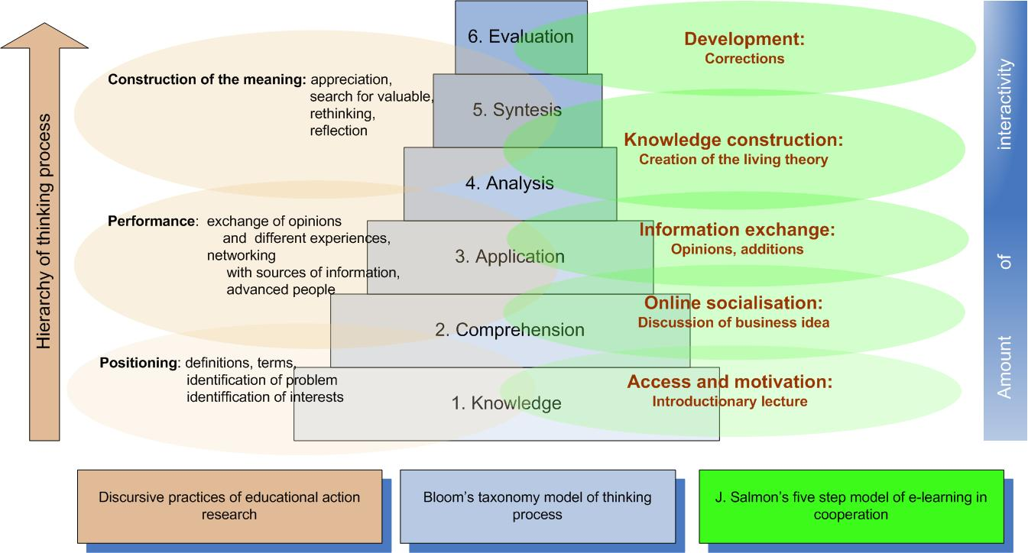
Figure 3. The correspondence of Bloom’s taxonomy (Bloom, 1956) and G. Salmon’s five–step model of collaborative e–learning (Salmon, 2002) with the discursive practice of action research (Kapenieks, 2010b).

Level 1. In the initial stage of action research, the students have introductory lectures to provide the necessary level of knowledge for cognition and get acquainted with the notions, basic relationships and practical examples of successful and unsuccessful practice that can be found in information resources. At this stage, it is important for the students to identify their own interests on which they might base their business idea. The following stages of mastering the course form the basis for discussions and knowledge construction. The students have to acquire the skills to remember, identify and perceive concrete information. At this preparatory stage for action research, it is important to create the motivation for involvement.
Level 2 is centered on creating the necessary level of comprehension of the acquired knowledge and skills to demonstrate it. It involves online socialisation through discourse and group discussions of the students’ business ideas in an e–learning environment resulting in shared comprehension. Level 2 corresponds to the performance stage in action research and involves new information obtained from stories of success and failure in business and discussions with experienced people.
Level 3. At this level, the acquired knowledge is applied in practice and information is exchanged in discourse with the group mates and with the e–learning consultant. Different views on the implementation of one’s business idea, its viability and sustainability in the long run are expressed. Exchange of experience takes place in the group and controversial views are expressed and substantiated. At this level, skills to use previously acquired knowledge in a new situation for problem solving are developed.
At level 4 of Bloom’s taxonomy, analysis is crucial in order to construct new knowledge. The student has to be able to evaluate his/her own ideas expressed in discourse and those of his/her group mates in order to synthesize and adequately apply them. At this level, the discursive practice of action research reaches the highest level of meaningful knowledge construction based on reflection, assessment and identification of relevant information.
Level 5, the level of synthesis corresponds to the knowledge construction step in G. Salmon’s model. At this level, the students integrate information and conceptions, draw new conclusions and make new judgements to perfect their business ideas. This process results in generating living theory — the outcome of the discourse integrating the ideas expressed and substantiated as well as the newly expressed ideas (Whitehead, 2009).
At level 6, the students assess the results achieved in action research. At this stage, the role of the study consultant is crucial. His/her reaction, views and corrections should be taken into account in starting the next action research cycle. This level corresponds to the final step of G. Salmon’s model — development.
Collaborative problem solving is task–focused. Preference should be given to collaboration which centers on symmetrical interaction. Collaborating the partners substantiate and evaluate various problem solutions (their collaboration is reflective) (Baker, 1997).
To perform the above mentioned tasks at all levels, the interface design of an e–learning environment should answer two basic requirements pertaining to functionality and user–friendliness. The main task of the interface is to ensure operation and development (Chapnick, 2005).
Requirements for functionality are based on three e–learning types (Clark, 2000):
- Bloom’s first two taxonomy levels — knowledge and comprehension — correspond to the receptive type of learning which is characterized by information retrieval. The interface design has to facilitate easy ways of finding information and presenting it on the screen, discarding redundant elements and avoiding the risk of overloading the cognitive system (Clark, 2007).
- Bloom’s third taxonomy level — application — corresponds to the directive e–learning type whose function is to acquire the skill to react. The essential features of this learning type are observation and action expressing themselves in minor steps taken, demonstrations and examples. The main requirement for screen functionality is that the interface should promote the creation of associations.
- Bloom’s highest taxonomy levels which involve synthesis of new knowledge and new insights correspond to the type of guided discoveries in e–learning. The students develop coherent mental representation both as an individual cognitive act and a collaborative act. The student’s task in guided discovery is to comprehend the presented problem and its solution. The key function of the e–learning environment interface is to support the development of mental representation. The e–learning consultant and the e–learning environment guide the student’s cognitive process. The consultant should not be an authority figure and suppress the student’s creativity but at the same time he should be easily accessible and guide the student’s progress.
Graphic solutions play an important role in ensuring functionality of the screen interface. The most important functions of graphics are: organising collaboration at the class, organising the themes and depicting relationships in order to promote the cognitive processes (Clark, 2003). The wide use of computers among the younger generation has developed their ability to perceive easily graphical information rather than texts.
One of the basic requirements for any interface is its user–friendliness. This term has been derived from the notion of usability by which we understand a parameter characterising the ease with which we use man—made objects. Its measurement is based on needs analysis. Often the usability of computer interface design is characterised by the basic principles defined by A. Lund which take account of the user’s character and the peculiarities of his perception, potential errors and the basic requirements of the cognitive system (Lund, 1997). R. Mayer has made a detailed analysis of interface design efficiency (Mayer, 2001). He distinguishes five basic principles having a great significance in facilitating perception.
- The contiguity principle suggests that the graphic image and the text explaining the image should be placed close to each other in order to avoid wasting cognitive resources on linking them up and overtaxing the operative memory resources. It refers also to feedback, task assignments and references, which should be placed together with the basic information without screening it.
- According to the modality principle, written explanations should be replaced by auditory explanations in order to use the auditory perception channels and avoid overloading the visual perception channels of sensory memory. As perception can be induced also by emotions, auditory perception gives the possibility to dramatise the material.
- The redundancy principle suggests that one and the same information should not be conveyed simultaneously as text and audio, for it may overload the channels of visual perception and hinder the perception of the graphic image. It is an important factor if essential information is conveyed in a graphic form.
- According to the coherence principle, preference is given to clear and concise presentations without adding interesting material unrelated to the information which has to be absorbed since it diverts the students from the main theme and overloads their working memory. The same refers to background music.
- According to the personalisation principle, which A. Lund also considers important, informal style is favoured. The student makes a greater effort to understand a concrete interlocutor whose role can be played by an animation personage or voice–over. In group collaboration personalisation can be embodied by an avatar (icon of a real person), it can be presented either in an audio or video form. The personalisation principle refers also to the participation of the e–learning consultant in group collaboration.
These principles and the views expressed by the students and the e–learning consultant involved in educational action research serve as a basis for the development of a new interface design.

4. Interface design for educational action research

The development of a user–friendly interface for educational action research in group work is based on two components: functionality and screen design. It refers both to the students’ interface and the interface of the e–learning consultant. In both cases, the above mentioned principles and screen design providing a sufficiently high and motivating level of comfort have to be observed. The students’ interface and that of the consultant should be simple and easy to use. It is important in order to avoid wasting time and intellectual resources on procedural activities so that they could be used for discourse and the synthesis of ideas and views (for the students) and for assessing and correcting the views expressed (the consultant). Interface functionality should be linked with G. Salmon’s five–step collaborative e–learning which in its stead is connected with the hierarchy of the thinking process in Bloom’s taxonomy model. The functionality for the students’ interface and the interface of the e–learning consultant for the e–learning environment proposed by the author of this study is shown in Figure 4 (Kapenieks, 2011c).

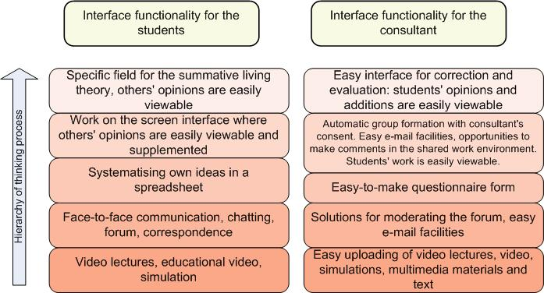
Figure 4. The functionality requirements for the interfaces of the students and the e–learning consultant in an e–learning environment corresponding to G. Salmon’s five–step model for collaborative e–learning and Bloom’s taxonomy of hierarchic thinking levels

The author’s study was performed in the Google Docs environment in which information is presented as tables similar to Excel spreadsheets. Group work was also recorded in tables registering the debatable business idea, the views added by the group mates, the living theory, the consultant’s commentaries and assessments. In a students’ poll only 13 % of them were satisfied with the design, 52 % of respondents considered it inconvenient. 17 % of respondents used this interface in their mobile phones but 13 % of the students said they were willing to use it in the phones, too. Though very few students considered the interface convenient, most of the students of the previous study year assessing its use gave it 4 points (in the scale from 1 to 5) (Figure 5). It seems that such a high evaluation of the interface can be explained by the interesting collaborative group work in implementing the action research method.

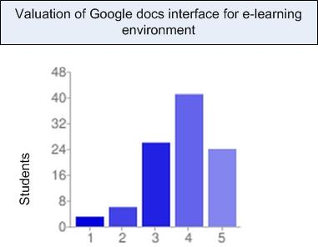

Figure 5. Students’ assessment of Google Docs user–friendliness in educational action research performed in the Business course using the scale from 1 to 5 (100 respondents)

Figure 6 reflects the students’ opinion on potential interface content changes (23 respondents). The diagram shows that the majority of students want to see only the necessary information and the opinion of the consultant in the interface.

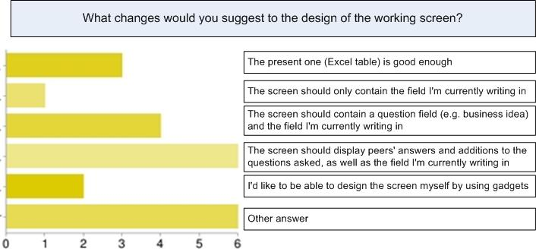

Figure 6. Students’ proposals for improving the interface (Kapenieks, 2011c).

35% of students would like group collaboration to be conducted using audio via a computer interface but 48 % would prefer video. At the same time, 74% of students consider also written text an appropriate form of group debates.The author of the paper who is also an e–learning consultant considers that the Google Docs study environment could be used though it has several serious drawbacks:
- Too many procedural activities have to be performed manually (breaking down the students’ table into group tables, their downloading, assigning them sharing rights);
- Time–consuming sending of motivational e–mails;
- Poor visibility of updates made by students in the table, when assessing and correcting their performance.
It is possible to update most of these functions by integrating automated functions. It would save the consultant’s time and he would be able to devote it to the analysis of the students’ performance. On the basis of the study, screen interface models for students and consultant’s were developed.

5. The architecture of the improved e–learning environment

For the needs of an e–learning environment, architecture consisting of customer — student and teacher/ consultant — workstations or mobile terminals, an external web server, Google account infrastructure, and Google Docs infrastructure is used. The e–learning environment design ensures the implementation of the following basic processes:
For the students:
• Student authentication;
• Entry of the students’ ideas;
• Test–poll about the students’ ideas, storage and retrieval of their results;
• Group creation and task assignment in student groups;
• Entry of the students’ additions (commentaries) into a user–friendly interface, their storage and presentation;
• Development of living theories in a user–friendly interface, their saving and presentation;
• Student monitoring of their group mates’ work and the teacher’s/ consultant’s commentaries;
• Communication.
For the teacher/ consultant:
• The teacher’s/ consultant’s authentication for access to the relevant tables in Google Docs,
• Indexing of the students’ entries in order to create the groups;
• Monitoring of the students’ work;
• Entry and storage of commentaries on the students’ performance;
• Entry and storage of the students’ work corrections and assessment;
• Communication.
Initially, the possibility of developing an e–learning environment architecture fully based on the technical capabilities of Google Apps applications using an open source solution for user authentication and authorisation, the development of gadgets, data storage and retrieval was considered. One of the most important principles is that all processes take place in an internet environment and that the only software that is necessary having on the computer is an internet browser. The design should provide convenient functionality also if a smartphone is used instead of the computer. However, the necessary volume of information and the requirement for its lucidity made us choose the computer as the basic tool.
After having analysed the potentialities offered by Google Apps, it was decided it could not ensure the necessary functionality for the planned interface design. The main problem was how to ensure a bi–directional data flow between the gadgets in the interface screen and the Google Document table storing the data. Proceeding from these considerations, architecture has been developed for an e–learning environment prototype in which data are stored in the Google Docs infrastructure as a table. For maintaining the interface, an external server is used. Figure 7 displays the data flow in the relevant prototype architecture.

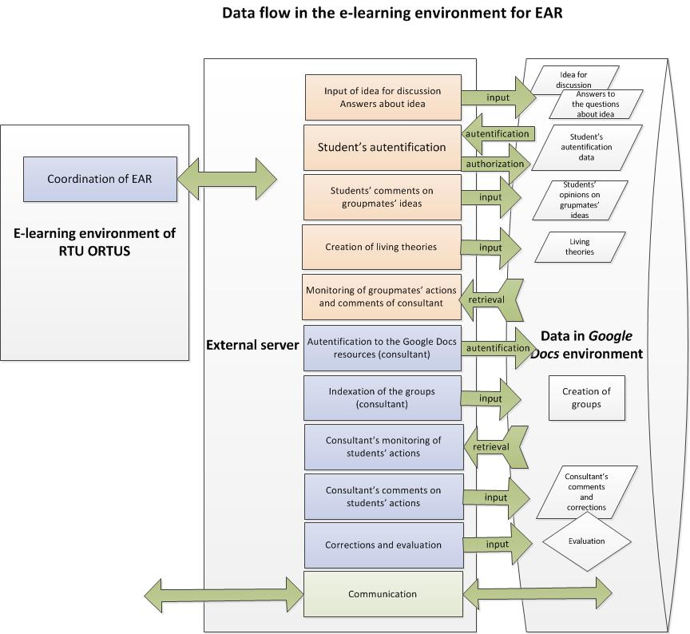
Figure 7. Data flow model of educational action research in an updated e–learning environment prototype.
Student authentication. For student authentication the OpenID (http://openid.net/specs/openid-authentication-2_0.html) protocol is used and the sub–processes displayed in Figure 8 are implemented:
1. The student opens the e–learning interface in his internet browser.
2. He/she requests the data after authentication using a Google account (pressing the respective on–screen button).
3. The interface server redirects the student’s browser to the Google account application: https://www.google.com/accounts/o8/id and requests the student’s e–mail address.
4. The Google account server authenticates the student, verifying whether the student has any objections to passing his/her e–mail address to the e–learning interface.
5. Google transfers the customer’s browser back to the e–learning interface web server together with the confirmation or rejection of the authorisation signed by using the HMAC-SHA256 algorithm.
6. The customer connects to the e–interface web server passing on the authorisation confirmation or rejection provided by the Google account server.
7. The web server verifies the authentication.

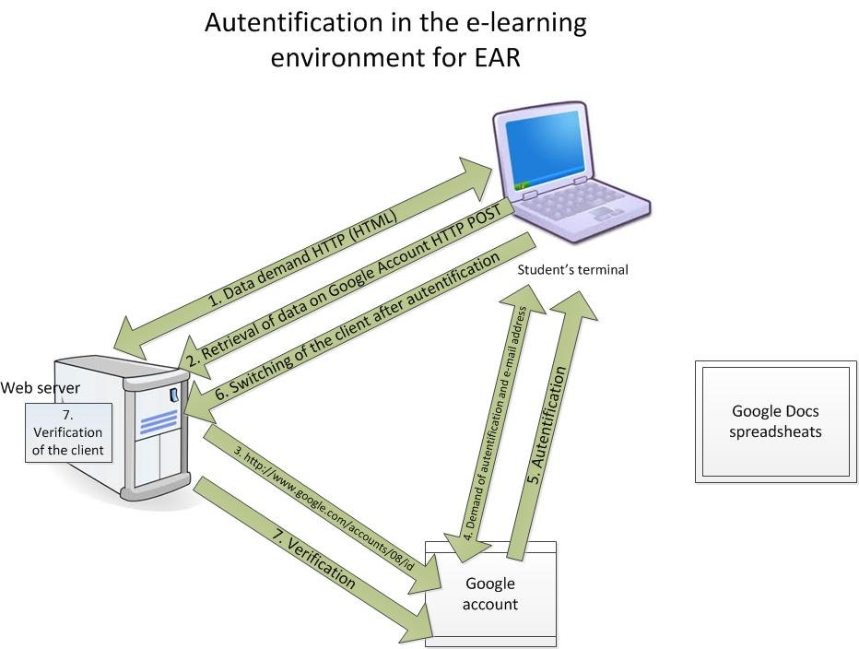
Figure 8. Sub–processes necessary for student authentication

Creation of groups, entry of the students’ additions and amendments. Figure 9 reflects the sub–processes for implementing the following activities:
• Creation of groups and task assignment in groups
• Entry of the students’ additions (commentaries) via a user–friendly interface, their storage and presentation.

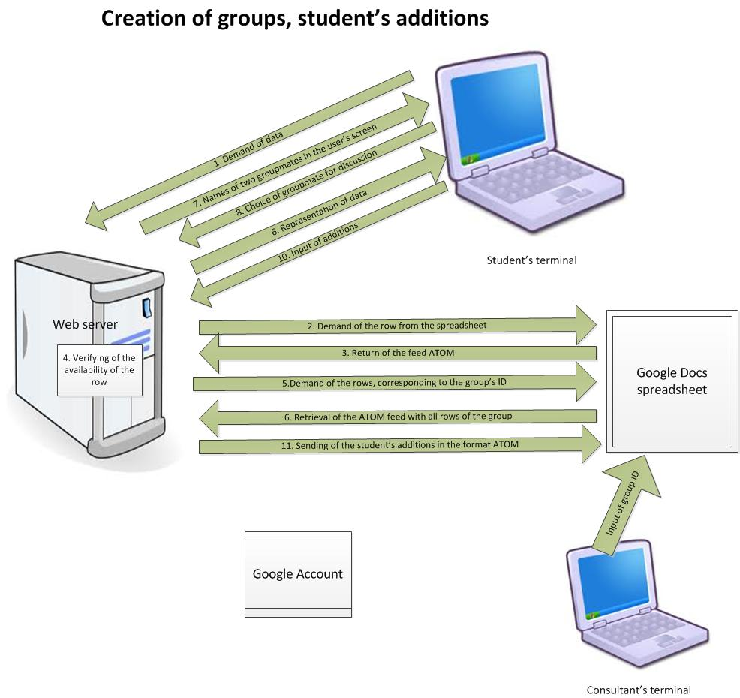
Figure 9. Sub–processes of creating student groups and of students complementing their group mates’ ideas.

1.Before creating groups, the teacher/ consultant enters the relevant group’s ID number for each student into the Google Docs spreadsheet table. After that,
The student opens the interface screen in an internet browser and authenticates himself/herself using his/her Google account and requests the necessary data in the http protocol HTML format.
2. The interface web server connects to the Google Docs infrastructure, performs the authentication using the service account indicated in the interface application (kaspis.test@gmail.com) and sends a request in the ATOM XML format to return the rows containing the student’s e–mail address from the spreadsheet table, whose indicator has been pointed out in the interface configuration.
3. An ATOM XML feed containing all table rows with the student’s e–mail address is returned.
4. The student checks whether at least one row (the student’s entry) has been returned, reads the group’s ID number and if it has not been entered, gives due notice. It means that the group has not been created yet.
5. Using the relevant group ID, the student requests all rows from the spreadsheet table (similar to the sub–process 2).
6. He/she receives the ATOM feed containing all rows of the relevant group.
7.The student’s on-screen interface shows a menu with the names of two of his/her group mates who have entered the data one after the other or of the first and second student accordingly, if the data is entered by the last or penultimate student – the returned sequential number calculated as the excess value for the numbers of the group’s students (n), adding 1 and 2, and dividing the result by the number of students in the group (k), i.e. (n+1)mod k and (n+2)mod k, where n is the student’s sequential number in the spreadsheet in the order of its filling out, and k is the number of students in the group.
8. In the interface screen, the student chooses the group mate (of two group mates offered) whose idea he wants to complement.
9. In the student’s browser, data are reproduced (the idea and answers to the questions about it) which have been entered by the chosen group mate.
10. The student enters his additions to the chosen group mate’s idea. They are sent in the ATOM format to the Google Docs spreadsheet table for storage in the relevant cells.
The environment design software has been developed using the Microsoft Visual Studio 2010 integrated programming environment.

6. The improved interface design prototype

The study has resulted in the development of an e–learning environment EAR prototype. The prototype was developed in three phases.
In the first phase, an interface design model was developed on the basis of the above mentioned study and the EAR experience. In the second phase, e–learning environment architecture and a data flow model were developed. In the third phase, on the basis of models developed in the previous phases, a prototype was programmed using Microsoft Visual Studio 2010 software.
The student’s interface. The student’s interface consists of 3 screens:
1. A screen for entering the initial information. The debatable idea and answers to the basic questions about it are entered into a form offered by Google Docs. Most students consider this format convenient.
2. An interface for group work. This screen provides the possibility to view the necessary information, to enter the additions in a text, audio or video format, and to communicate with the consultant. The page design is based on gadgets. The following aspects of personalisation have been stressed in the page design model (Figure 10):
• The interface screen shows only personalised information necessary for the respective procedure;
• The students can deploy the gadgets and change their size as they wish;
• Their group mates’ profiles are accessible from the interface screen;
• The student has a possibility to use the additions in a video format.

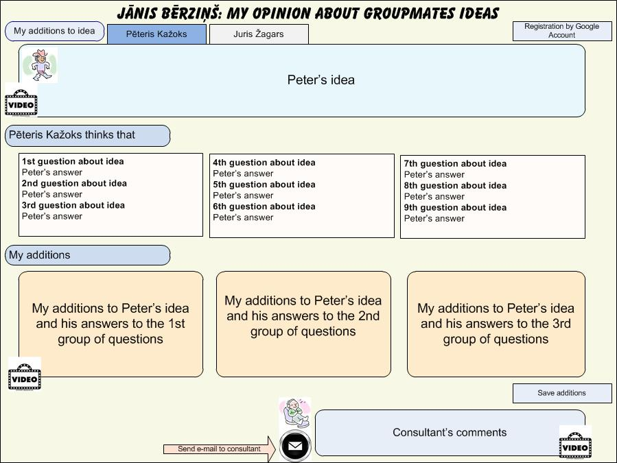
Figure 10. Student interface screen model for group work in educational action research

The interface screen prototype developed according to this model, which displays a group mate’s menu to be complemented, the student’s business idea, answers to the basic questions, additions in written and video format are seen in Figure 11.
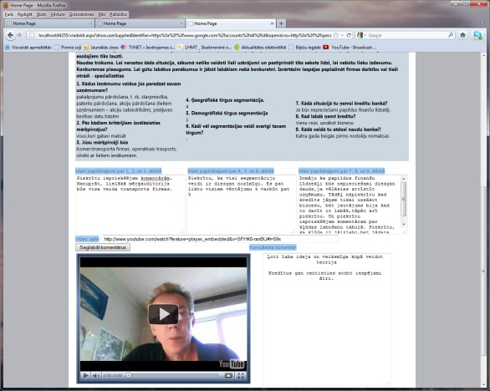
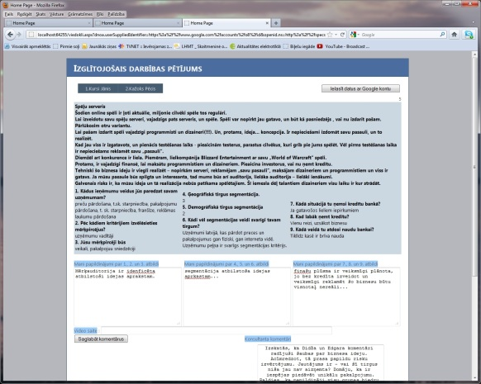

a) b)
Figure 11. Student interface screen draft for group work in educational action research using the prototype of an e–learning environment: a) without using video capabilities; b) using video commentaries.

3. An interface screen used for generating living theory (Figure 12). It gives the possibility to examine, in an easily surveyable way, the views of the student’s group mates on issues connected with his/her business idea. If necessary, there is an opportunity to view the relevant video file whose icon is active only in case the additions have been included in a multimedia format. The student can survey his own answers entered at the beginning of action research as well as the consultant’s commentaries. There is also an easy way to send an e–mail to the consultant. The student enters his living theory into this screen and it is stored in the database.

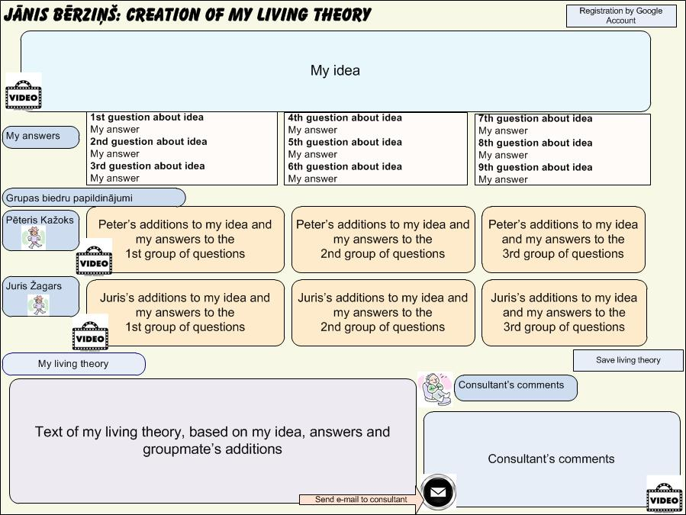
Figure 12. The student’s interface screen for generating living theory in educational action research

Conclusions

The educational action research method in an e–learning environment is an expression of the modern era which is characterised by the entrance of information and communication technologies into education and everyday life. Numerous studies have shown that knowledge generation in action research promotes the students’ activity in group work and develops their creativity and research skills. It has a great impact on the students’ personalities increasing their interest in creative activities and encouraging them to take on responsibility. The cognitive processes in educational action research include all levels of the thinking process hierarchy pointed out in B. Bloom’s taxonomy which in their stead correspond to G. Salmon’s five–step model of collaborative e–learning.
Wide application of the educational action research method in an e–learning environment requires a corresponding internet infrastructure and interface both for the students and the e–learning consultant. The interface design should be not only attractive and user–friendly but it should also correspond to the necessary thinking hierarchy level. The interface design should facilitate the cognitive processes without overloading the students’ and the consultant’s information perception channels and working memory.
The basic principles of interface design are determined by:
• Man’s cognitive and metacognitive skills;
• The requirement that both auditory and visual perception should be effectively used;
• The respective levels of B. Bloom’s taxonomy;
• Specific requirements for educational action research;
• EAR objectives — personal development and efficient group work stimulating reflection and creativity;
For EAR group work in an e–learning environment, besides the interface design principles defined by R. Mayer — the contiguity, modality, redundancy, coherence and personalisation principles (Mayer, 2001) — several other principles important for a collaborative environment have been outlined in the study:
1. The contiguity principle lies at the basis of the interface screen design which provides communication opportunities with the teacher/ consultant as well as quick answers to questions. The personal involvement principle in collaborative group work corresponds to R. Mayer’s personalisation principle. In an EAR group, it promotes close personal collaboration, the possibility to take advantage of the group mates’ profiles, the opportunities of quick communication and the use of videos to illustrate and personalise one’s views. This principle is important for the second and third levels of B. Bloom’s taxonomy which manifest themselves in online socialisation and exchange of views in which the identification of the expressed views with the personalities of concrete students even though in reality they meet seldom is a motivating element.
2. According to the blank leaf principle, it is not advisable to place statements expressed by authorities into the screen interface since it hinders the students’ creativity. According to this principle, the interface should offer sources and tools for discussion.
3. The comparison principle gives the student the opportunity to take advantage of the motivating role of his/her group mates’ activities and monitor (browse) their achievement in the same interface design in which he/she works.
The observance of these principles in the interface should be combined with several pedagogical requirements for the EAR process:
1. According to the non–interference principle, the teacher/ consultant should not interfere with the students’ decisions (it demotivates the students) but instead he/she should collaborate with them. It is especially important at the third and fourth level of B. Bloom’s taxonomy, which centers on exchange of views and knowledge construction in EAR (Figure 3).
2. “Strike while the iron is hot” principle — group formation should be prompt, the students should not wait long for the involvement of their group mates into collaborative work (waiting demotivates students).
The interface screen models have been developed in a way that allows implementing these principles with maximum efficiency.

References

Ala-Mutka, K., Bacigalupo, M., Kluzer, S., Pascu, C., Punie, Y., Redecker, C. (2008). Learning2.0: The Impact of Web2.0 Innovation on Education and Training in Europe: Report on a validation and policy options workshop organised by IPTS. Seville, IPTS.
Baker, M., Lund, K. (1997). Promoting reflective interactions in a computersupported collaborative learning environment. Journal of Computer Assisted Learning(13): 175-193.
Bess, K. D., Fisher, A. T., Sonn, C. C., Bishop, B. J. (2002). Psychological sense of community: research, applications, and implications. New York; London, Kluwer Academic/Plenum Publishers.
Bloom, B. (1956). Taxonomy of Educational Objectives. Handbook 1: Cognitive Domain. New York, David McKay.
Bonk C., C. D. (1998). Searching for Learner-Centered, Constructivist, and Sociocultural Components of Collaborative Educational Learning Tools. Electronic collaborators: Learner - centered technologies for literacy, apprenticeship, and discourse. K. K. Bonk C. New York, Lawrence Erlbaum Associates: 25 - 50.
Cedefop, E. C. f. t. D. o. V. T. (2008). Future skill needs in Europe. Medium-term forecast. Luxembourg, Office for Official Publications of the European Communities.
Chapnick, S., Meloy, J. (2005). Renaissance eLearning. San Francisco, Pfeiffer.
Clark, R. C. (2000). Four architectures for learning. Performance Improvement 39(10): 31-37.
Clark, R., Mayer, R. (2003). E-Learning and the Science of Instruction. San Francisco, Pfeifer.
Clark, R., Mayer, R.Richard (2007). E-learning and the science of instruction: proven guidelines for consumers and designers of multimedia learning, San Francisco, Pfeiffer.
Dewey, J. (1997). Democracy and Education. New York, Free Press.
Dewey, J., Benntley, A. (1949). Knowing and the Known. Boston, Beacon Press.
Dick, B., Stringer, E., Huxham, C. (2009). Final reflections, unanswered questions. Action Research 7(1): 117-120.
Dillenbourg, P. (1999). What do you mean by "collaborative learning"? What do you mean by "collaborative learning"? P. Dillenbourg. Amsterdam, NL, Pergamon, Elsevier Science: 1-16.
Ferrari, A., Cachia, R., Punie, Y. (2009) Innovation and Creativity in Education and Training in the EU Member States: Fostering Creative Learning and Supporting Innovative Teaching.
Genat, B. (2009). Building emergent situated knowledges in participatory action research. Action Research 7: 101-115.
Hansen, D. (2002). Dewey's conception of an environment for teaching and learning. Curriculum Inquiry 32(3): 267 - 280.
Herold, D. K. (2009). Digital na(t)ives - Discourses of exclusion in an inclusive society. The good, the bad and the challenge. Copenhagen, Denmark.
Kapenieks, J. (2010). Action reserch for creating knowledge in e-learning environment. 8th International JTEFS/BBCC conference “Sustainable development. Culture. Education”, Paris, France, Saule.
Kapenieks, J. (2011a). Knowledge creation: action research in e-learning teams. IEEE EDUCON 2011 "Learning Environments and Ecosystems in Engineering Education" Ammann, Jordan, International Assciation of Online Engineering.
Kapenieks, J. (2010). Action reserch for creating knowledge in e-learning environment. 8th International JTEFS/BBCC conference “Sustainable development. Culture. Education”, Paris, France, Saule.
Kapenieks, J. (2011c). E-learning environment for sustainability in educational action research. 9th International JTEFS/BBCC Conference " Sustainable development. Culture. Education", Šiauliai, Lithuania, Šiauliai University.
Kaptelinin, V., Nardi, B., Macaulai, C. (1999). Methods & tools: The activity checklist: a tool for representing the “space” of context. Interactions 6(6): 27-39.
Loveless, A. M. (2007). Creativity, technology and learning – a review of recent literature. from http://archive.futurelab.org.uk/resources/documents/lit_reviews/Creativity_Review_update.pdf.
Loveless, A. M. (2008). Creative learning and new technology? A provocation paper. Creative Learning, London, Creative Partnerships.
Lund, A. (1997). Expert ratings of usability maxims. Ergonomics in Design 5(3): 15-20.
Mayer, R. E. (2001). Multimedia Learning. New York, Cambridge University Press.
Nielsen, J. (1993). Usability Engineering. San Francisco, Academic Press.
Prensky, M. (2005). "Engage Me or Enrage Me": What Today's Learners Demand. Educause Review 40: 60-65.
Robinson, K. (2011). Out of Our Minds. Learning to be Creative. Chichester, UK, Wiley.
Rogers, C. (1983). Freedom to learn for the 80's. London, Merrill.
Roschelle, J., Teasley, S. (1995). The construction of shared knowledge in collaborative problem solving. Computer-supported collaborative learning. C. O'Malley. Berlin, Germany, Springer Verlag: Springer Verlag.
Salmon, G. (2002). E-tivities. London, Kogan Page.
Stahl, G., Koschmann, T., Suthers, D. (2006). Computer-supported collaborative learning: An historical perspective. Cambridge handbook of the learning sciences. R. Sawyer. Cambridge, UK, Cambridge University Press.
UNESCO (2005). Towards Knowledge Societies. Paris, UNESCO Publishing.
Whitehead, J. (2009). Generating living theory and understanding in action research studies. Action Research 7(1): 85 - 99.

